Conversion Techniques

Conversion from Binary to Other Number Systems
Binary Numbers are represented with digits 0 and 1 and with base 2. Conversion of a number system means conversion from one base to another. Following are the conversion of the Binary Number System to other Number Systems:

- Binary to Decimal Conversion
Binary numbers are represented in base 2 but the decimal numbers are of base 10. Hence, to convert the binary number into a decimal number, the base of that number is to be changed. Follow the steps given below:
- Step 1: Multiply each digit of the Binary number with the place value of that digit, starting from right to left i.e. from LSB to MSB.
- Step 2: Add the result of this multiplication and the decimal number will be formed.
Example: To convert (11101011)2 into a decimal number
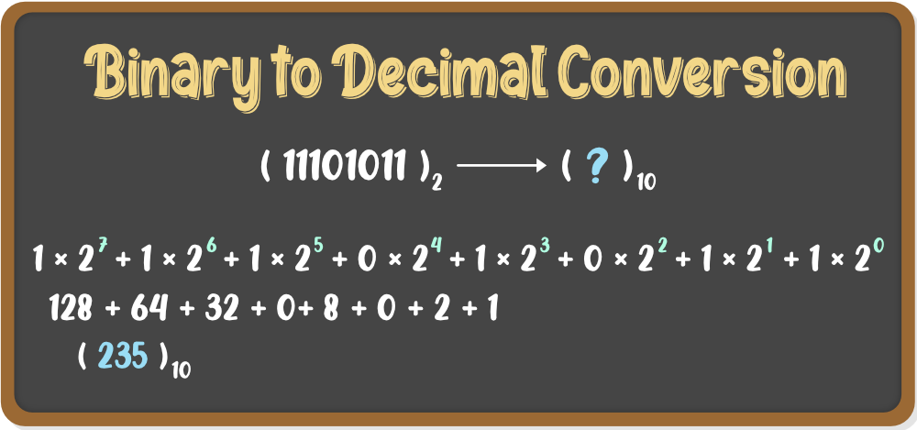

Binary to Octal Conversion
Binary numbers are represented in base 2 but the octal numbers are of base 8. Hence, to convert the binary number into octal number, the base of that number is to be changed. Follow the steps given below:
- Step 1: Divide the binary number into groups of three digits starting from right to left i.e. from LSB to MSB.
- Step 2: Convert these groups into equivalent octal digits.
Example: To convert (11101011)2 into an octal number
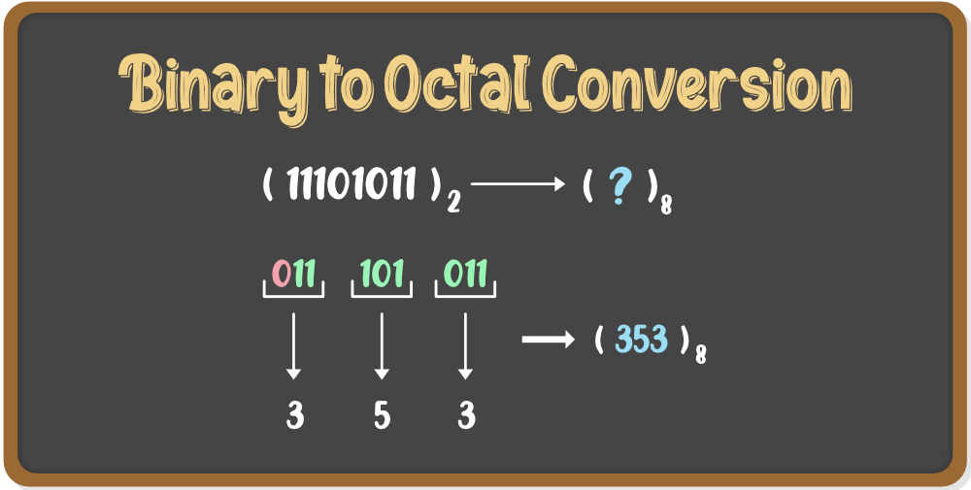

Binary to Hexadecimal Conversion
Binary numbers are represented in base 2 but the Hexadecimal numbers are of base 10. Hence, to convert the binary number into Hex number, the base of that number is to be changed. Follow the steps given below:
- Step 1: Divide the binary number into groups of four digits starting from right to left i.e. from LSB to MSB.
- Step 2: Convert these groups into equivalent hex digits.
Example: To convert (1110101101101)2 into a hex number
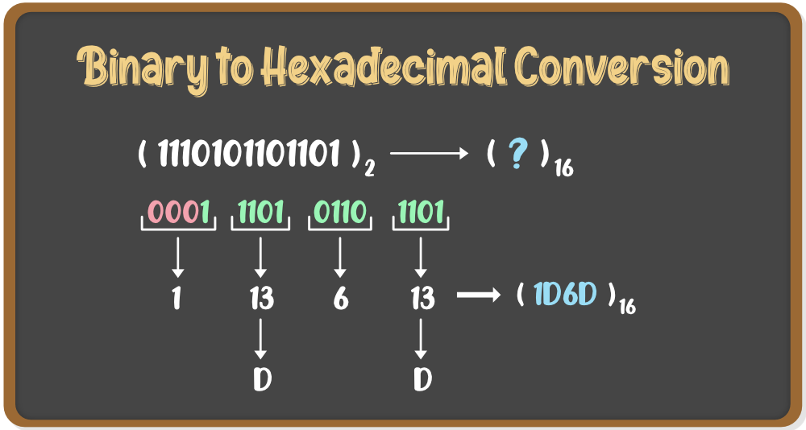

- Conversion from Octal to Other Number Systems

Octal Numbers are represented with digits 0-7 and with base 8. Conversion of a number system means conversion from one base to another. Following are the conversions of the Octal Number System to other Number Systems:

Octal to Decimal Conversion:
Octal numbers are represented in base 8, but the decimal numbers are of base 10. Hence, to convert an octal number to a decimal number, the base of that number is to be changed. Follow the steps given below:
Step 1: Multiply each digit of the Octal number with the place value of that digit, starting from right to left i.e. from LSB to MSB.
Step 2: Add the result of this multiplication and the decimal number will be formed.
Let’s see an example.
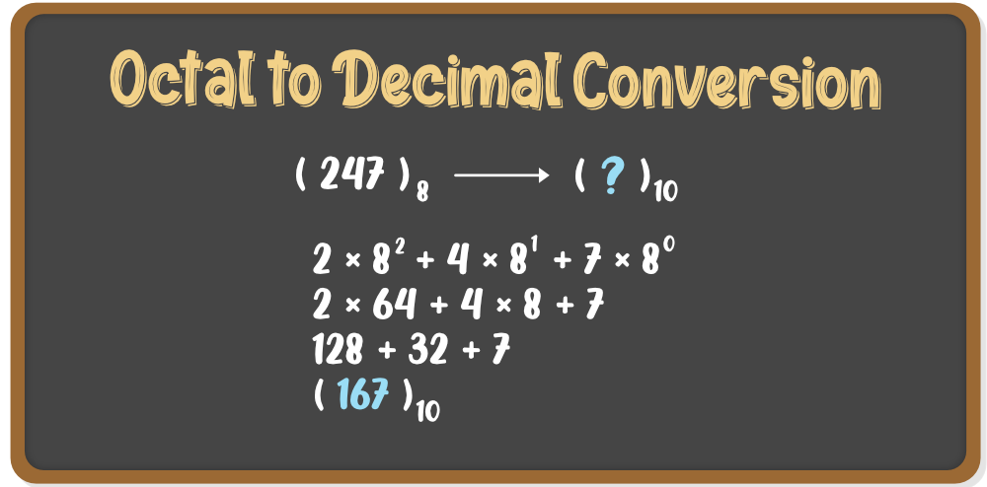

Octal to Binary Conversion:
Octal numbers are represented in base 8, but the binary numbers are of base 2. Hence, to convert an octal number to a binary number, the base of that number is to be changed. Follow the steps given below:
- Step 1: Write each digit of the octal number separately.
- Step 2: Convert each digit into an equivalent group of three binary digits.
- Step 3: Combine these groups to form the whole binary number.
Example: (247)8 is to be converted to binary
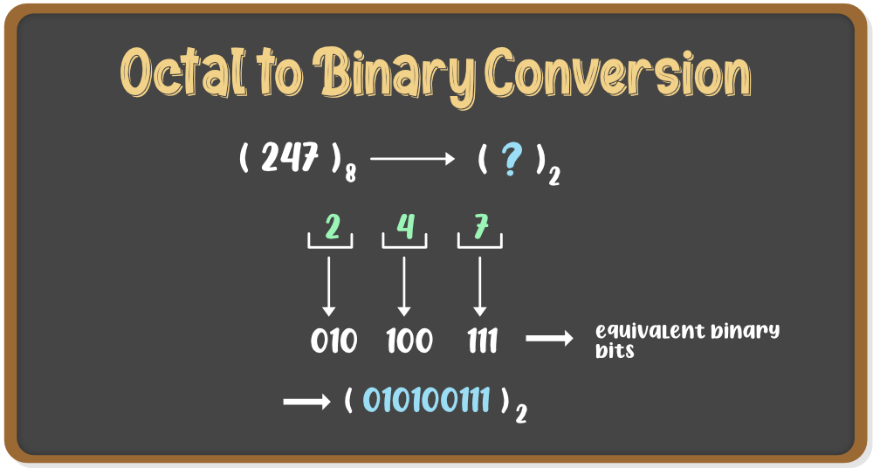

Octal to Hexadecimal Conversion:
Octal numbers are represented in base 8, but the hexadecimal numbers are of base 16. Hence, to convert an octal number to a hex number, the base of that number is to be changed. Follow the steps given below:
- Step 1: We need to convert the Octal number to Binary first. For that, follow the steps given in the above conversion.
- Step 2: Now to convert the binary number to Hex number, divide the binary digits into groups of four digits starting from right to left i.e. from LSB to MSB.
- Step 3: Add zeros prior to MSB to make it a proper group of four digits(if required)
- Step 4: Now convert these groups into their relevant decimal values.
- Step 5: For values from 10-15, convert it into Hex symbols i.e from A-F
Example: (5456)8 is to be converted to hex
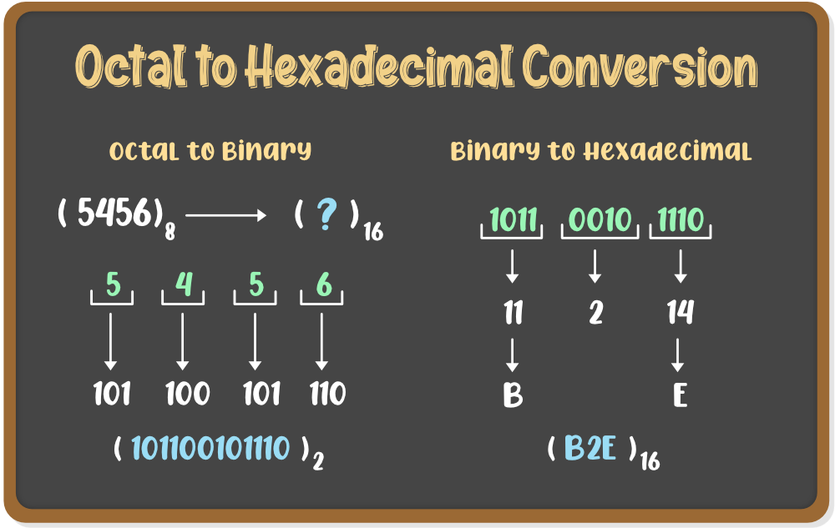

Conversion from Hexadecimal to Other Number Systems
Hex Numbers are represented with digits 0-9 and with letters A-F and with base 16. Conversion of a number system means conversion from one base to another. Following are the conversions of the Hexadecimal Number System to other Number Systems:

Hexadecimal to Decimal Conversion:
Hexadecimal numbers are represented in base 16 but the decimal numbers are of base 10. Hence, to convert a hexadecimal number to a decimal number, the base of that number is to be changed. Follow the steps given below:
- Step 1: Write the decimal values of the symbols used in the Hex number i.e. from A-F
- Step 2: Multiply each digit of the Hex number with its place value. starting from right to left i.e. LSB to MSB.
- Step 3: Add the result of multiplications and the final sum will be the decimal number.
Example: To convert (8EB4)16 into a decimal value
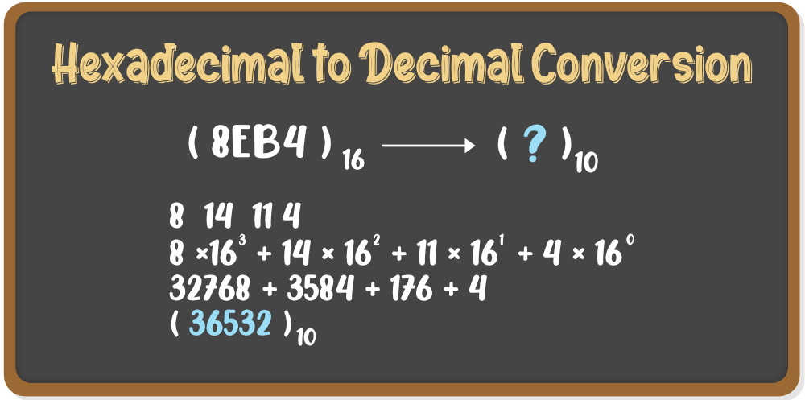

Hexadecimal to Binary Conversion
Hex numbers are represented in base 16, but the binary numbers are of base 2. Hence, to convert a hexadecimal number to a binary number, the base of that number is to be changed. Follow the steps given below:
- Step 1: Convert the Hex symbols into its equivalent decimal values.
- Step 2: Write each digit of the Hexadecimal number separately.
- Step 3: Convert each digit into an equivalent group of four binary digits.
- Step 4: Combine these groups to form the whole binary number.
Example: (B2E)16 is to be converted to binary
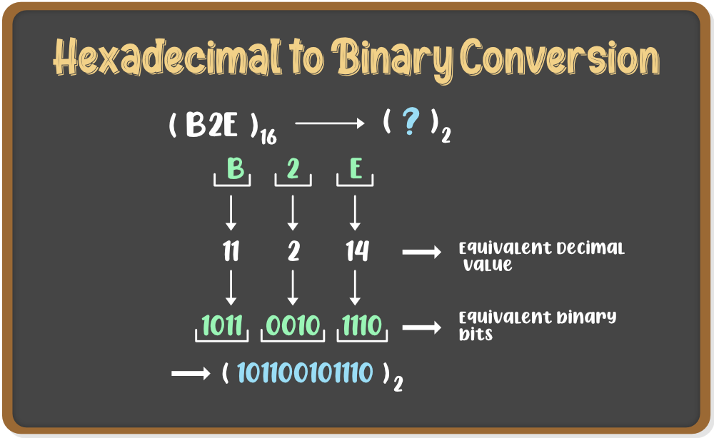

Hexadecimal to Octal Conversion:
Hexadecimal numbers are represented in base 16, but the octal numbers are of base 8. Hence, to convert a hex number to an octal number, the base of that number is to be changed. Follow the steps given below:
- Step 1: We need to convert the Hexadecimal number to Binary first. For that, follow the steps given in the above conversion.
- Step 2: Now to convert the binary number to Octal number, divide the binary digits into groups of three digits starting from right to left i.e. from LSB to MSB.
- Step 3: Add zeros prior to MSB to make it a proper group of three digits(if required)
- Step 4: Now convert these groups into their relevant decimal values.
Example: (B2E)16 is to be converted to hex
